本教程向您展示如何创建一个数据网格（datagrid）和内联编辑器。

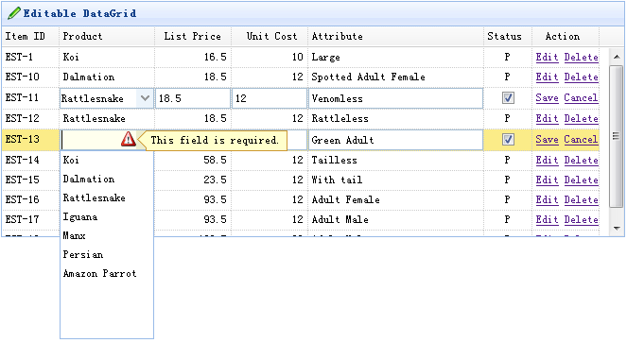

#### 创建数据网格（DataGrid）

    $(function(){

        $('#tt').datagrid({

            title:'Editable DataGrid',

            iconCls:'icon-edit',

            width:660,

            height:250,

            singleSelect:true,

            idField:'itemid',

            url:'datagrid_data.json',

            columns:[[

                {field:'itemid',title:'Item ID',width:60},

                {field:'productid',title:'Product',width:100,

                    formatter:function(value){

                        for(var i=0; i<products.length; i++){

                            if (products[i].productid == value) return products[i].name;

                        }

                        return value;

                    },

                    editor:{

                        type:'combobox',

                        options:{

                            valueField:'productid',

                            textField:'name',

                            data:products,

                            required:true

                        }

                    }

                },

                {field:'listprice',title:'List Price',width:80,align:'right',editor:{type:'numberbox',options:{precision:1}}},

                {field:'unitcost',title:'Unit Cost',width:80,align:'right',editor:'numberbox'},

                {field:'attr1',title:'Attribute',width:150,editor:'text'},

                {field:'status',title:'Status',width:50,align:'center',

                    editor:{

                        type:'checkbox',

                        options:{

                            on: 'P',

                            off: ''

                        }

                    }

                },

                {field:'action',title:'Action',width:70,align:'center',

                    formatter:function(value,row,index){

                        if (row.editing){

                            var s = '<a href="#" onclick="saverow(this)">Save</a> ';

                            var c = '<a href="#" onclick="cancelrow(this)">Cancel</a>';

                            return s+c;

                        } else {

                            var e = '<a href="#" onclick="editrow(this)">Edit</a> ';

                            var d = '<a href="#" onclick="deleterow(this)">Delete</a>';

                            return e+d;

                        }

                    }

                }

            ]],

            onBeforeEdit:function(index,row){

                row.editing = true;

                updateActions(index);

            },

            onAfterEdit:function(index,row){

                row.editing = false;

                updateActions(index);

            },

            onCancelEdit:function(index,row){

                row.editing = false;

                updateActions(index);

            }

        });

    });

    function updateActions(index){

        $('#tt').datagrid('updateRow',{

            index: index,

            row:{}

        });

    }

    function getRowIndex(target){

        var tr = $(target).closest('tr.datagrid-row');

        return parseInt(tr.attr('datagrid-row-index'));

    }

    function editrow(target){

        $('#tt').datagrid('beginEdit', getRowIndex(target));

    }

    function deleterow(target){

        $.messager.confirm('Confirm','Are you sure?',function(r){

            if (r){

                $('#tt').datagrid('deleteRow', getRowIndex(target));

            }

        });

    }

    function saverow(target){

        $('#tt').datagrid('endEdit', getRowIndex(target));

    }

    function cancelrow(target){

        $('#tt').datagrid('cancelEdit', getRowIndex(target));

    }